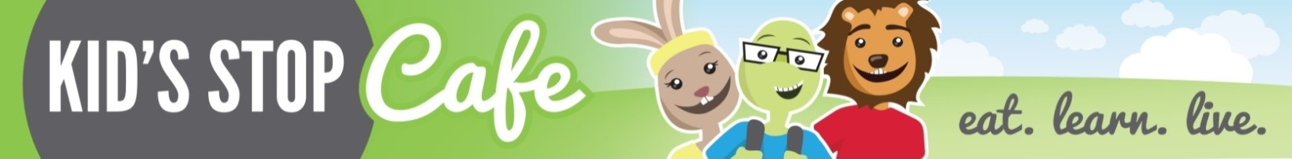
Hazel Park Schools
Remote Learning
January Breakfast Menu
Breakfast and Lunch are FREE for Students

Monday | Tuesday | Wednesday | Thursday | Friday
4  Bagel w/Cream Cheese  String Cheese  Milk | 5  Breakfast Grahams  Yogurt  Milk | 6  Muffin  String Cheese  Milk | 7  Cereal Bowl  Yogurt  Milk |  | 8  Cereal Bar  String Cheese  Milk
11  Bagel w/Cream Cheese  String Cheese  Milk | 12  Breakfast Grahams  Yogurt  Milk | 13  Muffin  String Cheese  Milk | 14  Cereal Bowl  Yogurt  Milk | 15  Cereal Bar  String Cheese  Milk
18  Bagel w/Cream Cheese  String Cheese  Milk | 19  Breakfast Grahams  Yogurt  Milk | 20  Muffin  String Cheese  Milk | 21  Cereal Bowl  Yogurt  Milk | 22  Cereal Bar  String Cheese  Milk
25  Bagel w/Cream Cheese  String Cheese  Milk | 26  Breakfast Grahams  Yogurt  Milk | 27  Muffin  String Cheese  Milk | 28  Cereal Bowl  Yogurt  Milk | 29  Cereal Bar  String Cheese  Milk

Contact Marsha Dziewit with any questions at (248)658-5995 or marsha.dziewit@hazelparkschools.org
Weekend Meals are Chef’s Choice

