Hello ladies!
First and foremost, thank you for your willingness to contribute your time and efforts to the cause for Hazel Park School children. We sincerely appreciate you!
My name is Robin Dunlop, the proud Nana of a Hazel Park Jr. High 8th grader (as of 9/2020), and have been sewing since I was 12 yrs. old-taught by my British-born Nana (from the Victorian era!). I’m happy to assist with any questions you may have with these instructions. Contact Stephanie Dulmage or Amy Kruppe for contact information-again, thank you!
There are 2 styles that I’ve included for you to review and choose from.
#1 – Pleated rectangle: 1-yard of fabric at 45” wide will yield 10 masks
Supplies needed: Med/Large: Cotton fabric folded to 8.5”high x 8”wide
2 pcs of elastic: each 9.5” long
4” wire (garden wire from $1 store is 75ft)
Or ties from bread, ties from kitchen garbage bags (any length mostly)
Small: Cotton fabric folded to 7.5” high x 7” wide
2 pcs of elastic: each 8.5” long
4” wire (garden wire from $1 store is 75ft)
Or ties from bread, ties from kitchen garbage bags (any length mostly)

You can cut a total of 4 across the length of the yard, then fold up the next group you are doing. Now you will have a
strip of fabric approximately 10” wide left over for which you may cut 2 length-wise pieces. (cotton is forgiving).
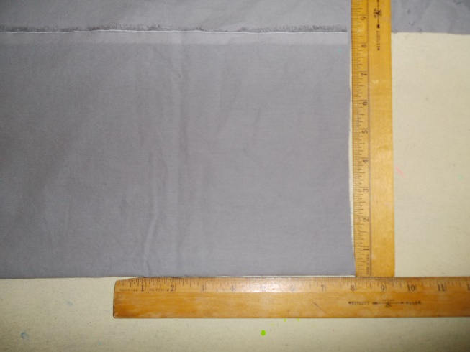

- Sew seam closed, right sides together (won’t matter for solids, same both sides)
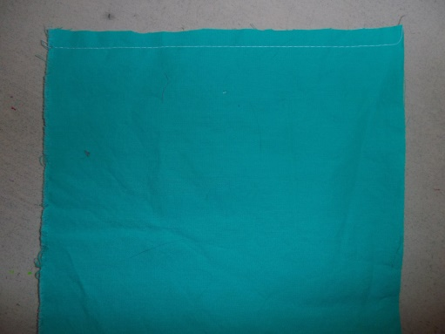

- Turn right side out and fold ½” down and press.
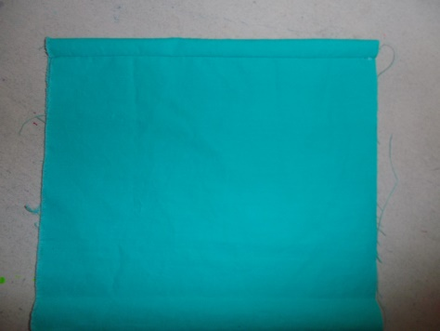

- Slide the straightened wire (if from a roll of wire) in and center (about 2” is left each side)
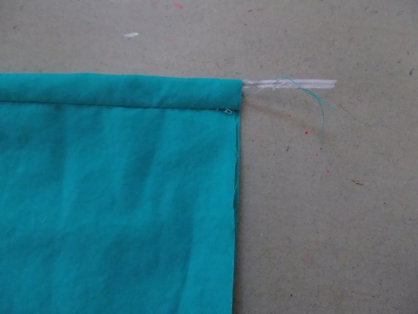

- Stitch 3/8-1/2” from edge encasing the wire, and continue on all the way around.
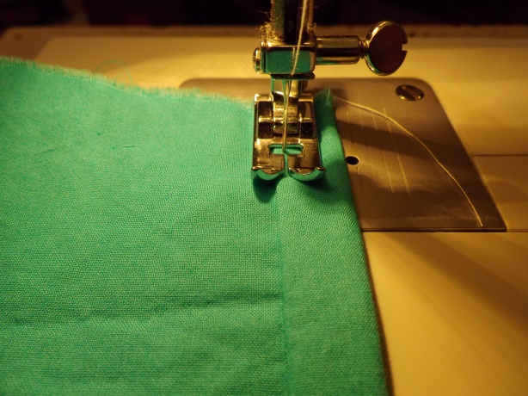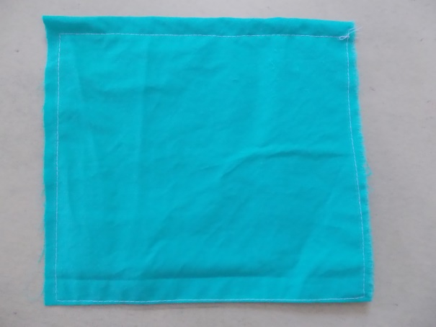

- Press 3 pleats (with the casing seam as the side toward the face) and stitch the pleats down each side.

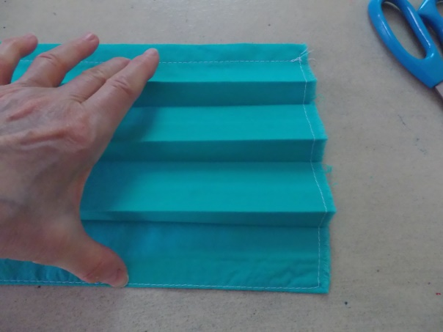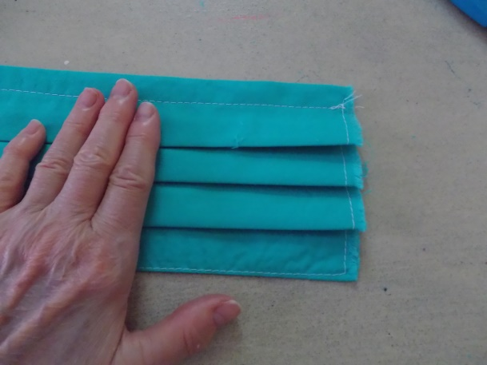
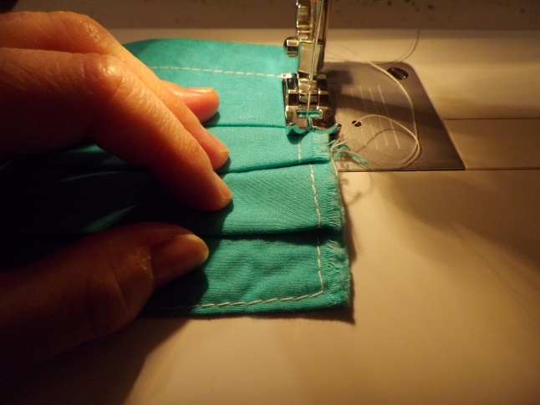
- If you have a serger, serge the side edges. If not, trim clean and use a ‘wide’ zigzag, set at a bit shorter than normal stitch length – trim all threads.
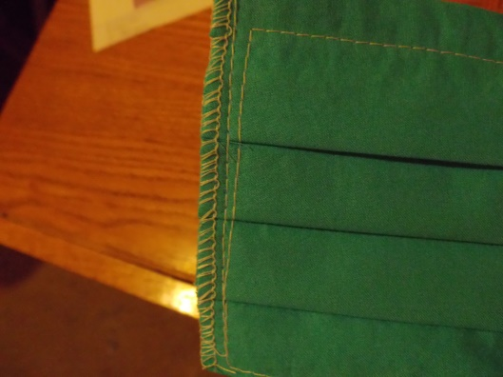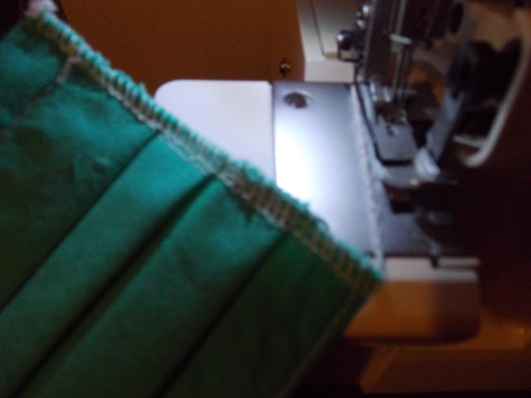

- Insert the mask into the elastic and fold the end over the elastic ½” and stitch down backstitching each end.
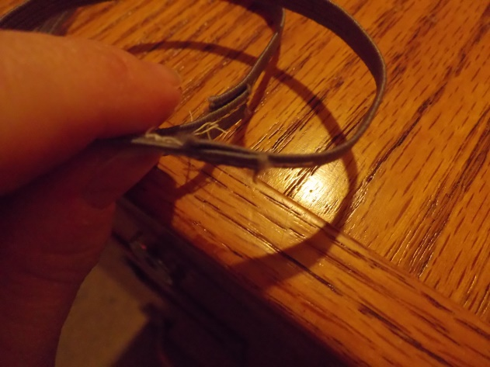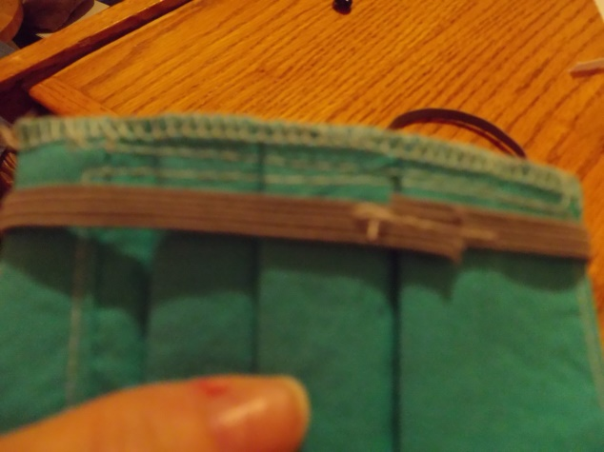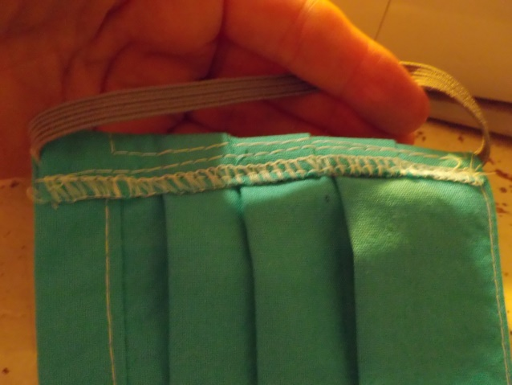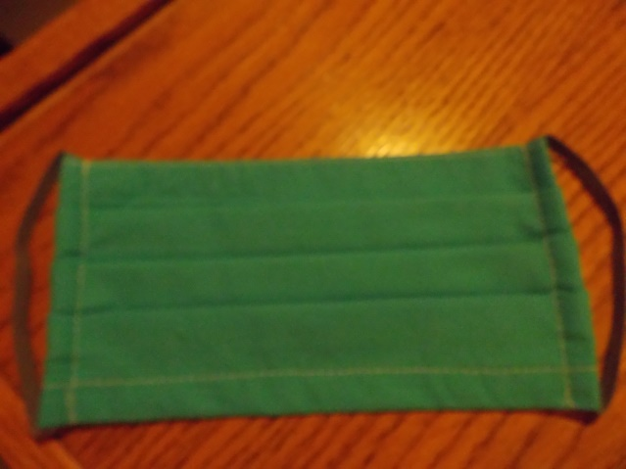
All done and ready to wear!!!!!

