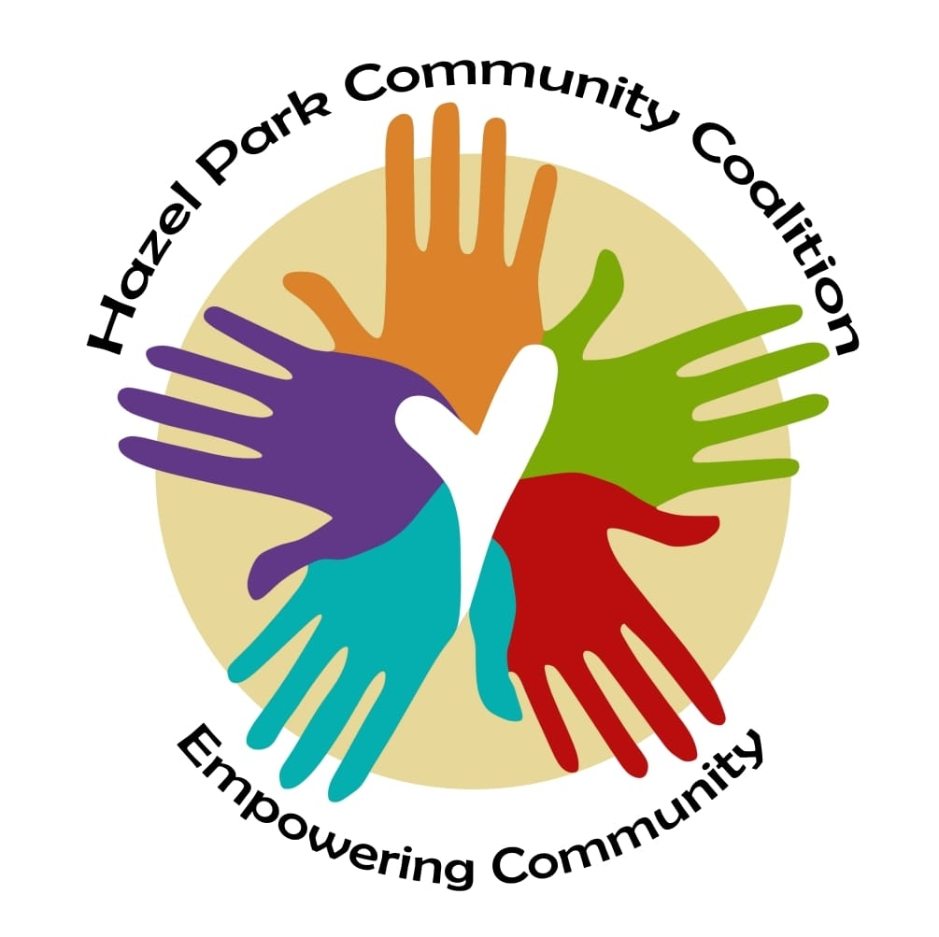

Yoga and Meditation Permission Slip and Waiver

I hereby agree to the following:

My child has permission to attend a yoga/meditation class at Scout Park in Hazel Park, Michigan and/or via Zoom in case of inclement weather.

My child is participating in classes or services during which she/he will receive information and instruction about yoga and health. I recognize that yoga requires physical exertion, which may be strenuous and may cause physical injury, and I am fully aware of the risks and hazards involved. I understand that it is my responsibility to consult with a physician prior to and regarding my child’s participation in any physical fitness program, including yoga. I represent and warrant that my child has no medical condition that would prevent her/his participation in physical fitness activities.

In consideration of being permitted to participate in the yoga/meditation classes, I agree to assume full responsibility for any risks, injuries or damages, known and unknown, which my child might incur as a result of participating in the program. In further consideration of being permitted to participate in the yoga/meditation classes, I knowingly, voluntarily, and expressly waive any claim I may have against the instructor, the organization by which he/she is employed, the owner, or the leaseholder of the facility for injuries or damages that my child may sustain as a result of participating in classes or workshops held with the Hazel Park Community Coalition.

I have read the above release and waiver of liability and fully understand its contents. I voluntarily agree to the terms and conditions stated above.

Parent’s or Guardian’s Name |  |  | Child’s Name
Parent’s or Guardian’s Signature and Date |  |  | Child’s Date of Birth |  | Child’s Gender
Parent’s or Guardian’s Phone Number |  |  | Parent’s or Guardian’s Email Address
Please list any medical concerns the yoga teacher should be aware of:

